|  |  |  |
| --- | --- | --- |
| SCHOOL OF INFORMATION AND TECHNOLOGY | | |
| BUSONGAN, DEMIRAYE-ANNE | DATE PERFORMED: 11 SEPT 2024 |  |
| IDC1 | DATE SUBMITTED: 11 SEPT 2024 |

# SYSADM1 – Managing Services in Linux

# Requirement:

* A virtual machine running Linux

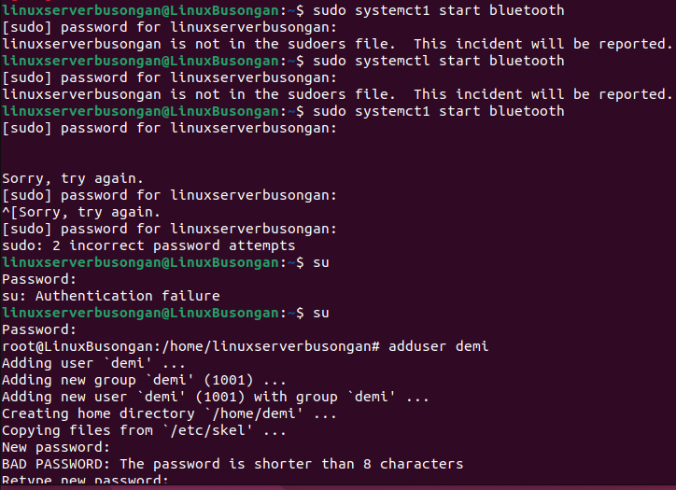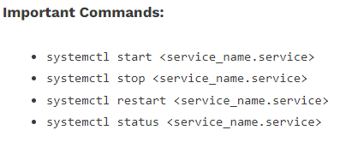  
NOTE TO DEMI (VERSION 22):   
 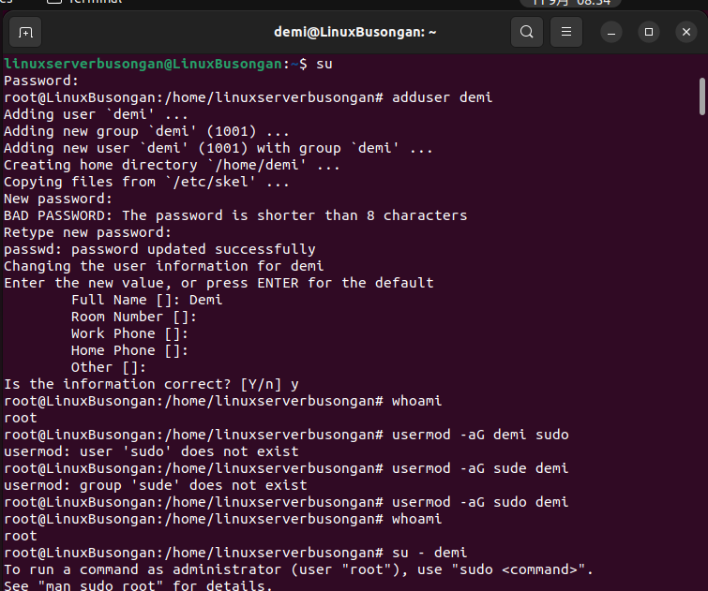

Complete this lab as follows:

Use the service-–status-all command to list all active and inactive services.

List down active and inactive services in the table below. Provide five (5) services for each column.

|  |  |
| --- | --- |
| **Active** | **Inactive** |
| (+) acpid | (-) alsa-utils |
| (+) cups | (-) bluetooth |
| (+) cups-browsed | (-) speech-dispatcher |
| (+) dbus | (-) keyboard-setup.sh |
| (+) openvpn | (-) hwclock.sh |

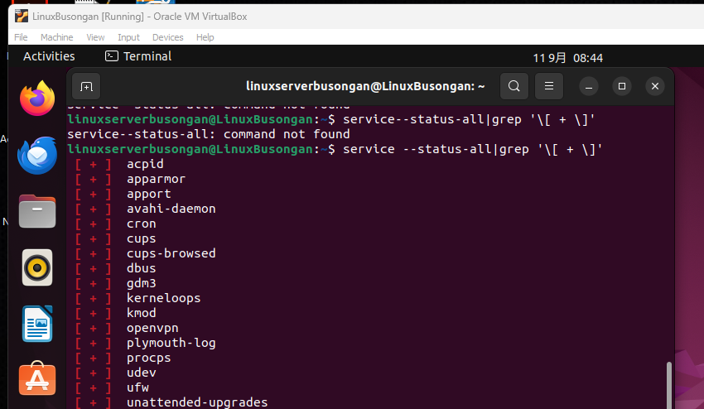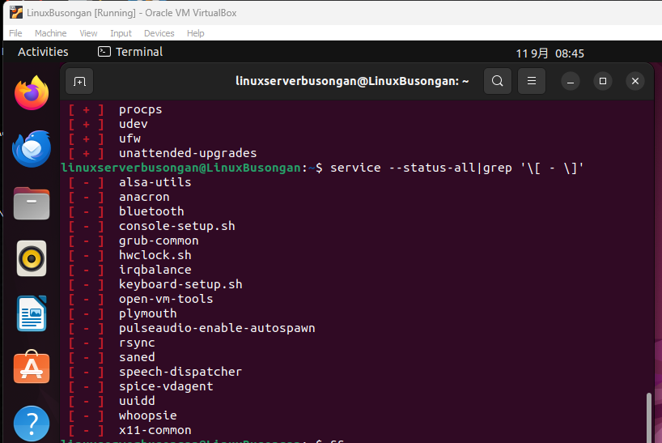  
Note: service –status-all|grep ‘[-\]’, service –status-all|grep ‘[-\]’

Start the Bluetooth service using the systemctl command.

Ex. sudo systemctl start httpd (Version 2024)

* Sudo modprobe Bluetooth  
  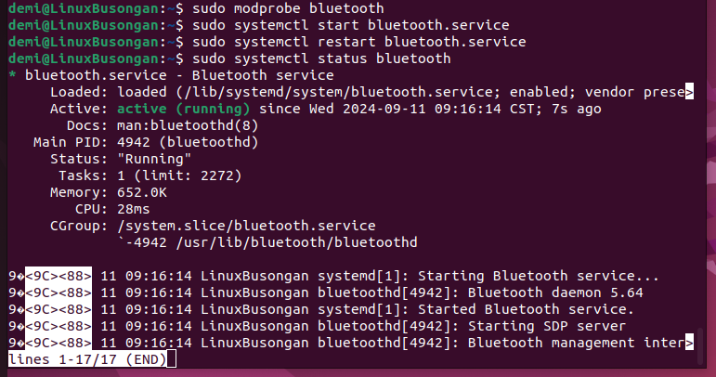

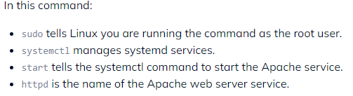

Check the status of the Bluetooth service. What is its status?

* We could see from the image below that the Bluetooth is currently inactive or dead

SS: 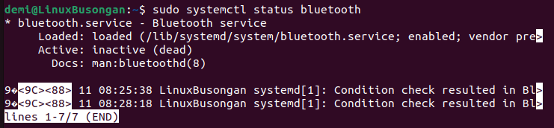

Check the status of the cups services. Since when was it running?

* Based on the image the service cups Started Running on Wednesday 2024-09-11 at exactly 8:25 CST, 41mins prior.

SS: 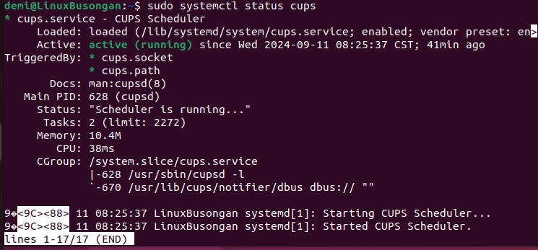

Stop cups services. **(SS in NUMBER 6)**

Verify if the service was stopped. 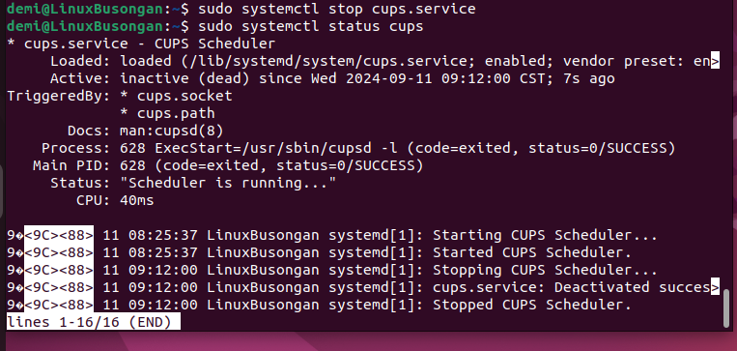

Restart the cups services **(SS in NUMBER 8)**

Verify if the service was restarted.

